COLLEGE SAATHI

(Your College Buddy)

ELC ACTIVITY

­­­­­­­



App Development

(102003424) Aditya Singh Rathore

(102003431) Deepankar Varma

(102003445) Sarisha Aggarwal



Computer Science and Engineering Department

TIET, Patiala

INDEX

1. Problem Statement ................................................................................... 3
2. Solved Objective. ...................................................................................... 4
3. Technology Stack ...................................................................................... 5
4. App Interface ............................................................................................ 6

PROBLEM STATEMENT

Our project ‘College Saathi’ dedicates itself to solving the various daily necessity inside a college campus. It consists of facilities such as vendor details, important college contacts, upcoming event details, rickshaw ride booking, ride history, location finding within campus temperature, humidity, etc.

SOLVED OBJECTIVE

* College Saathi is a handy mobile application to help college students with all the essentials required to get familiar with the campus and its surroundings.
* Students must register on the app via email and password, and their data integrity will be maintained.
* The student must provide further details (like enrolment number and name ) in the app for verification by the college.
* The app would provide details about nearby shops for daily necessities such as groceries, stationery, etc.
* College updates regarding the latest events within the campus would be in the Upcoming Events section on the home page
* Any student who wants to book a rickshaw can do that by going to the book rickshaw option on the main page.
* Students can access various college events, details of multiple shops, and essential contact details just by signing in to College Saathi.

TECHNOLOGY STACK

*Frontend* : Flutter

*Frontend programming language* : Dart

*Database* : Google Firebase

*Backend Service* : Firebase Authentication

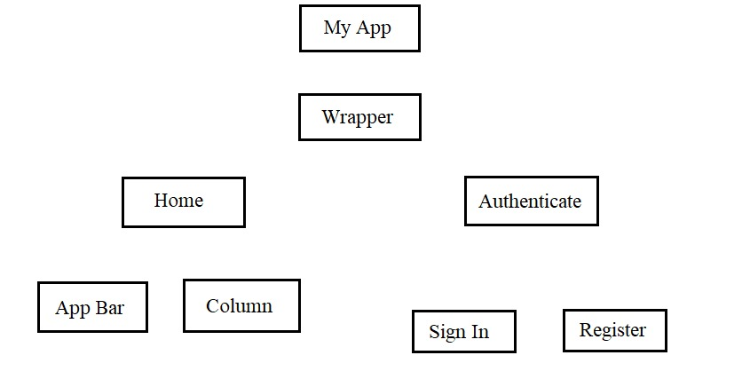

APP INTERFACE

Login Page Home Page

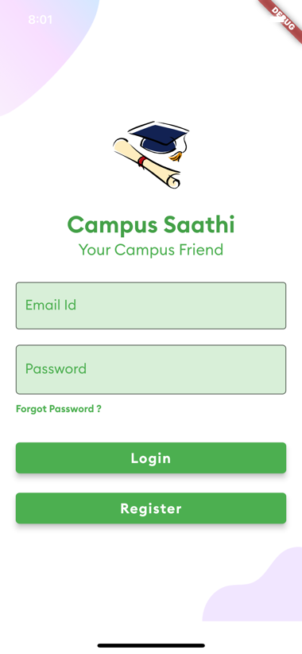 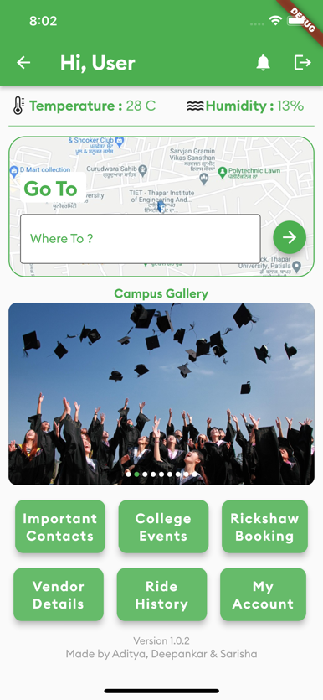

Important Contacts Events Booking

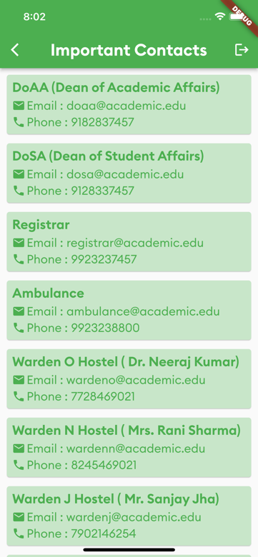 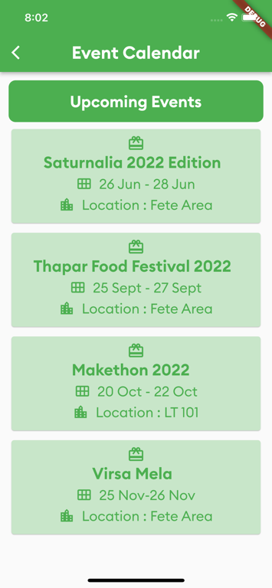 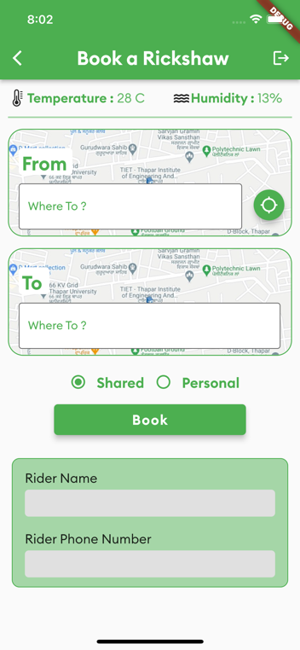

VENDORS

Foods Stationery General

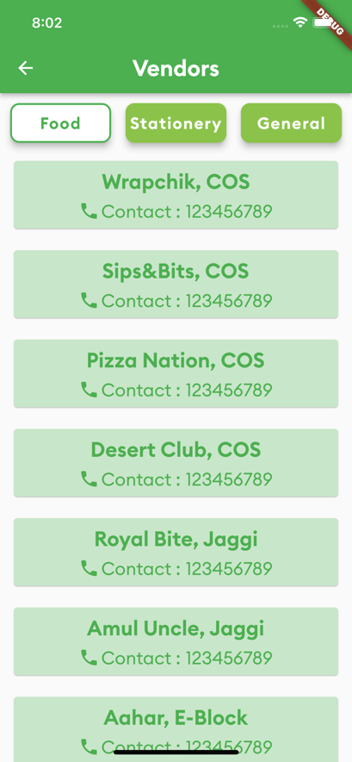 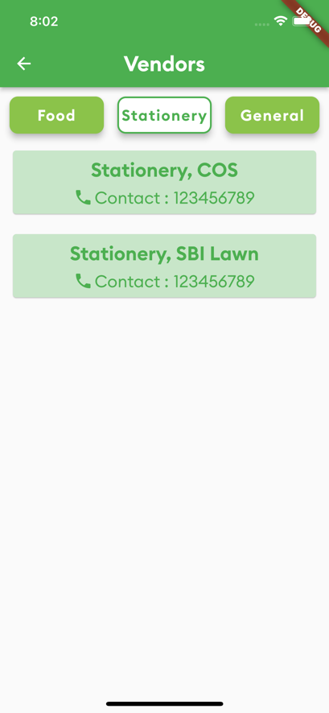 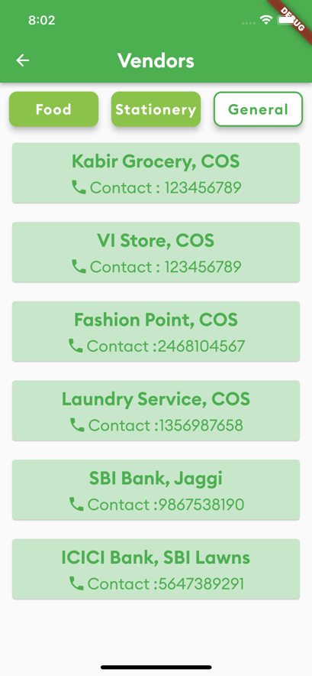

Ride History User Profile

